Case Studies 2013-14
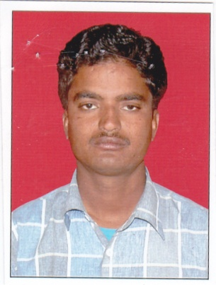
Case Study 1-
Name : Mohammad Farid
Speaker: Khatun Baigam (His mother)
Address – S/o Late Shri Suban Ali, Alipura, Gram Panchayat Nagelov, Panchayat Samiti Peesangan, District Ajmer, State Rajasthan, INDIA
Age : 23 yrs
Sex : Male
Type of disability: Partially Hearing and Speech Impairment
Educational qualification: Fifth
Marital Status: Married
Occupation: Electrician
Category: APL
Reason to select: Being literate and trained people take advantage of him in his profession.
Background:
Infant: Since birth Mohammad Farid suffering with a disability of partially hearing and speech. His inability to hear and speech was recognized when he was six months old. Family members try to attract him by making some sound with his toys but they realized that there is no reaction of the action. His mother told that as per doctor at the time of delivery some medicine was injected which affected his hearing ability as a result he lost his hearing power. Other than this disability he is fit to do all other physical work.
Childhood: During his childhood when he was sent to school, all the students and teachers do not treat him well and were not able to provide full facilities. Other students’ parents say that if this child will study in the school then our children will not be able to study well. His teacher told that ‘all the time we have to concentrate on him so that he may understand something. Instead for such type of special child there are special schools he should be admitted in that special school where his development will be much better.’
Mohammad Farid was able to study up till 5th standard in the general school. After that his father expired as a result even though he wanted to study but nobody from the family supported for his further education.
Teenage: He lives with his mother in a joint family. Their house is pacca house and it belongs to their grandparents. As he lives in joint family he used to support the family by assisting them in agricultural field and grazing animals. Earlier he used to graze them but now due to his disability we feed the goats at home. One day he went to graze his goats one of them was caught hold in the thorny bush, it screamed a lot but he did not heard. Other person who was passing by heard the scream and save the goat.
Gradually, his uncle i.e. his father’s younger brother taught him electric and pipe fitting job so that he may do some of his own job from home. But due to financial problem he was not able to do on his own. Thereafter, he was appointed as a labour in a shop. For his job work he goes with someone who can communicate with people.
Problems Faced:
- Being a special child he was not able to complete his education within village.
- During his job work people used to cheat him and take his advantage by not paying him his complete amount. For example – As he is good at work people used to call him from home by saying that they will pay good amount (Rs.1000/-) but after completing the job they pay him half the amount i.e. only Rs. 500/-. Out of which Rs.300/- is spent on motor cycle for petrol if the service place is far. He used to be in stress.
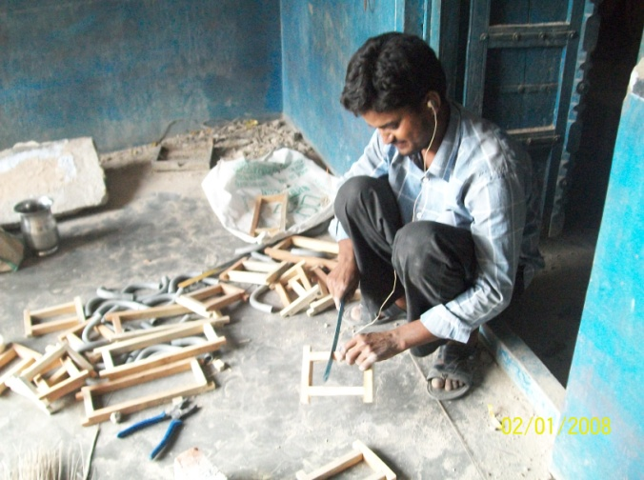
Present:
As the organization came to our village PWDs were made aware about their rights and schemes. Thereafter, PWDs’ SHGs were formed. He also joined the group. Through the group his medical card, smart card was mad with this his pension was also started. He also applied for loan and equipped with hearing aid machine.
The major benefit which he received was through hearing aid machine. With its help now he can hear the sound. People also don’t dare to cheat him as they know that now he can listen everything. He ware it every time especially when he goes for his job. Now he is happy as now he can fulfill his family needs on time.

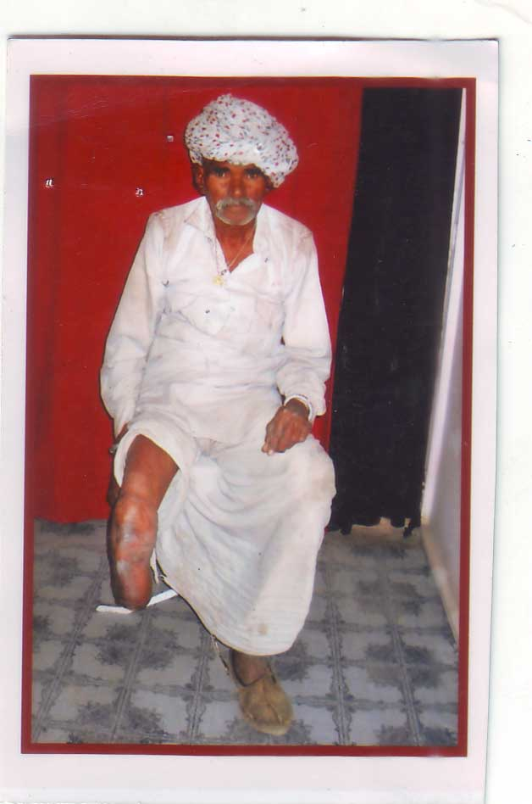
Case Study 2-
Name : Magna
Address: S/o Shri Nanu ji, Village Gola, Gram Panchayat Gola, Panchayat Samiti Peesangan, District Ajmer, State Rajasthan
Age : 60 years
Disability: Physical (by leg – 60 %)
Caste: Gujar
Marital Status: Married
Type of family: Joint
Source of Income and Income: Agriculture and animal husbandry (Rs. 4000/- per month)
Education: Non-literate
Background:
I am a resident of Gola village and by profession I am a farmer. Income earned through agriculture assist us to earn our daily bread. But twenty years ago, in bus accident I lost my one leg. Now I am helpless to do any of my jobs, I am unable to walk properly. I have become dependent on others. It’s good that my family members are supportive that whenever I want to go somewhere they go with me otherwise I mostly remain at home and do some work at home.

Problems faced:
Due to my disability I have become dependent and unemployed. As mobility is the great problem. I am unable to do agriculture work or go to market.
Present Situation:
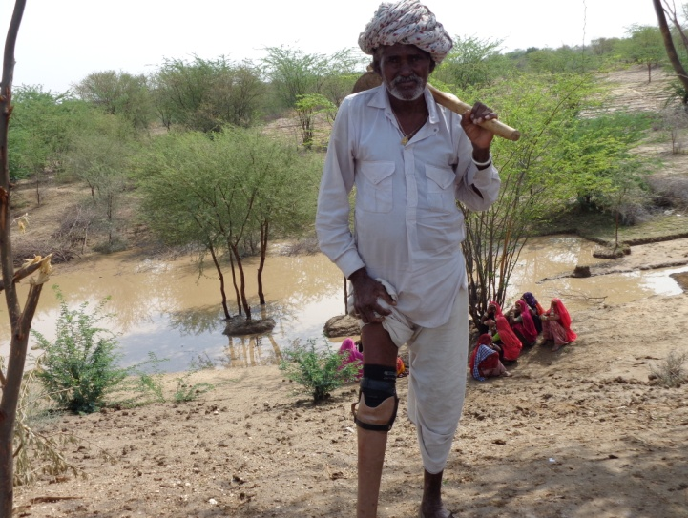
As the organization came to our village PWDs were benefited in many ways. They linked us with government schemes and assisted us to fight for our rights at panchayat level. They also formed groups for PWDs as well as women so that they may become self dependent and work as a pressure group. Group members save Rs 100/- every month and try to fulfill their needs by inter-loaning. I also joined the group and gained benefits of it. I did not have any proof of my disability, the organization assisted me in getting my Medical Card and thereafter Smart Card. Now I am getting government benefits. The organization helped me to get artificial leg, now I have again become independent. I can walk and do my work on my own even I help others. As before I go to my farms and take care of my livestock.
Support the organization and any suggestion:
I will motivate other PWDs to join the group and strengthen it and inform them about the benefits which the organisation has provided to me. I will suggest the organization to assist in agriculture and livestock development along with some entrepreneurship development for PWDs in which less strength is required for example: work of pattal done, shops, etc.

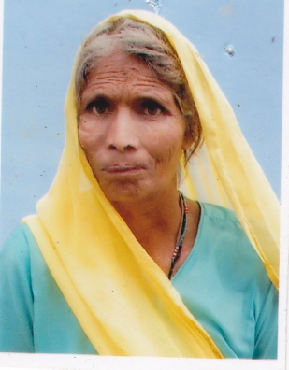
Case Study 3-
Name:Mrs.Ram Kanya
Address: W/o Kalu Ram Yadav , Village Devliya Kala, Panchayat Samiti Bhinay, District Ajmer, State Rajasthan, INDIA
Age : 48 yrs
Sex : Female
Type of disability: Mental Illness
Educational qualification: Non-Literate
Occupation: Nil (Her family members ask her to do household work, to graze their livestock, timber from forest and to get water from distance and in exchange they provide her and her children food and cloth.)
Category: General
Reason to select: She is not mentally fit to think good about herself. Being married her husband also does not support her for her and her children wellbeing.
Background:
When she was 8 months old due to fever she became mentally ill. In childhood at the age of two she was married to a disable person. Her husband is also suffering from partial visual impairment. At the age of sixteen she went to her husband’s house. He is a drive so he often out migrates from his native place. Therefore, Mrs. Ram Kanya stays behind with her two children and in-laws. Her both children [(boy (10) and girl (20)] are also mentally ill. Being alone no one to back her, in-laws do not treat her properly and torture her. So at present she is staying in her parents’ house. Her daughter got married to a person who belongs to her mother’s family. She too has two children.
Challenges:
In her mother’s house she has two brothers and their wives. They both are quite good enough to earn their daily bread. Her father has expired and her mother is all alone who is unable to do her own work. Ram Kanya is the only one who takes care of her old mother. There is no one to listen and take care of her neither by her in-laws nor by her brothers and their wives. Whatever she is asked to do she calmly do and in exchange she simply get food and cloth support and not love and care.
Her son is mentally ill so he does not go to school instead he roam in the village.
Overcome from situation:
The organisation when started the project in their village she came to know that PwDs surveys are being done in the village, awareness programme are being organised. With this she gained her knowledge towards her rights and welfare scheme. Thereafter, when PwDs groups began to be formed she joined and participated in the meetings for her and her children wellbeing. She has also asked for assistance to get medical certificate, PwD’s pension, job card, astha card and smart card. This will help her to be economically empowered. The organisation has forwarded her application to the various concerned departments.
Positive and negative aspect:
- Gained knowledge from awareness programmes.
- Participates in PwDs group’s meetings from last 3-4 months.
- Linkage with the government schemes.
Lessons learned:
At initial stage various trainings and meetings, awareness programmes assisted PwDs to gain self-confidence to overcome their difficulties. Groups are formed to link persons with disabilities with government schemes for their socio – economic empowerment.
Suggestions that would help facilitate to overcome their situation:
- Job/ livelihood within village.
- Own house to live independently.

